University of Central Punjab
Faculty of Information Technology
Final Term Exam (CSSE3113): Introduction to Software Development (ISD)

Duration | Semester | Percent Weight | Total Marks
2h 30m | Fall 2023 | 40% | 40

Name : _______________________________ Reg #

INSTRUCTIONS
- This is a CLOSED BOOK and CLOSED NOTES exam; Cheat sheet is NOT ALLOWED.
- Attach this question paper with your answer sheet.
- There is a total of 9 questions, and 3 printed pages.
- CALCULATOR SHARING IS NOT ALLOWED
- Providing multiple solutions to a question is not allowed. If multiple answers are found, only the first un-crossed will be checked, and the remaining will be ignored.

Q1. | Create a use case diagram of a Restaurant management system. The diagram can have many actors but it must have the Staff, admin, receptionist and customers.  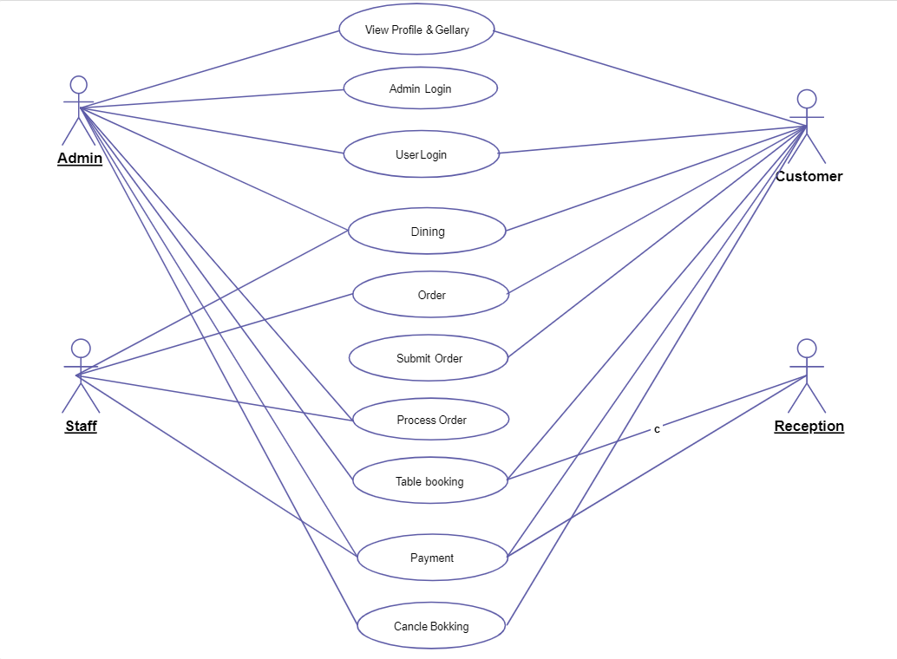 |  | [7]
Q2. | There are three Designs given for solving a problem of faster execution of customer queries in a banking system. Each has different Benefits and Costs. For the Table given in Figure 3.  - Compute the “Added value” when the company savings are $4500 per year.  - Compute the Return on Investment (for 1 year and 5 year)  - Compute the %gain on ROI (for 1 year and 5 year)  - Based upon the results of ROI, suggest which design is best choice for long term investment and which design is best choice for short term investment,  (Note: Added value is computed by calculating the additional requests per second that the system can process in a minute and multiplying that number with savings of company per year.)  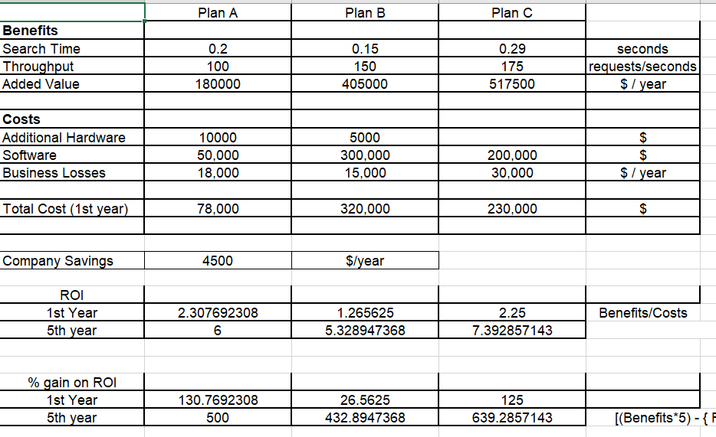  Formula for %gain for 5 years  =[(Benefits*5) - { Fix cost + (Per year cost * 5)} / { Fix cost + (Per year cost * 5)} ] x 100  Based on ROI, Plan A is best choice for short term and Plan C for Long term. |  | [2+2+2+2]
Q3. | Give 02 differences between Aggregation and Composition with example. (marks will be given based on example) |  | [2]
Q4. | Considering that you would like to buy a new 70cc bike and you have different alternatives as shown in the Table given in Figure 4.  Suppose your priority for defined criteria from top to bottom are 5,5,5,4,5,2,3,5,4,1.  Perform Trade-off analysis to decide which one is the best one for you.  (all calculations must be shown to get full marks)  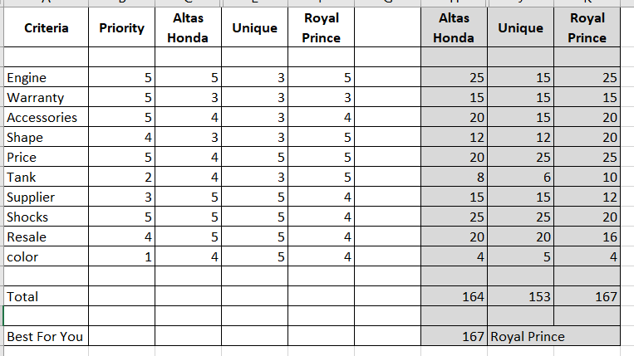 |  | [3+1]
Q5. | A software has a 3-point value-based Function Point estimation as shown in Figure 5.  - The adjustment factors of the 14 questions for a software application are: 5,1,0,4,3,5,5,5,4,4,2,3,4,2.  - The weight factor is simple if EQs < 5. The weight factor is average if EQs >= 5 and EQs <= 9. The weight factor is complex if EQs > 9.  - The average LOC per FP of technology used “Assembly language” is 320.  Calculate effort, development time and average staffing using CoCoMo. Suppose the software is developed with some restrictions and some creativity within the allowed boundary is allowed to achieve the goal.  Use Figure 1 for FP weights and Figure 2 for CoCoMo constants.  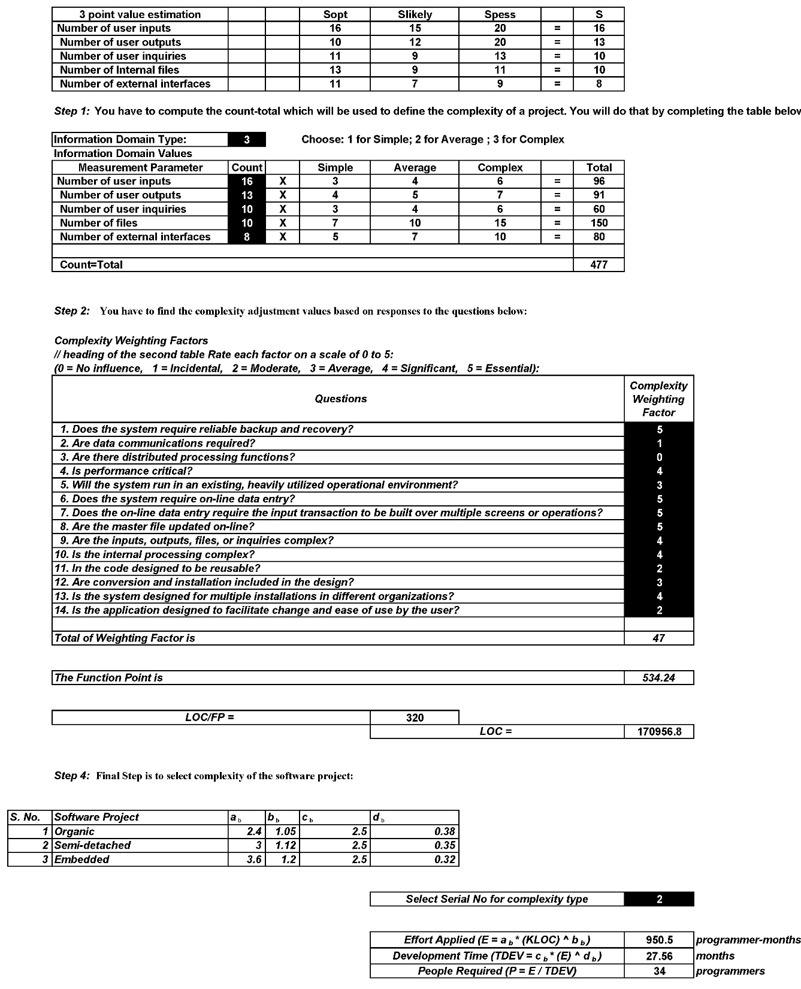 |  | [2+2+2+2]
Q6. | A project has a total of 121 requirements. The requirements are measured before going forward with the project. It is found that 36 requirements are of rating 1, 10 requirements are of rating 4, 10 requirements are of rating 5, 36 requirements are of rating 2 and the remaining are of rating 3.  - Are the requirements okay or they require revision  - Give reasoning for your answer  Solution:  The requirement require are OK and does not require revision.  Because more than 50% requirements are of rating 1 and 2, that is, 50% requirements are easy understandable. |  | [1+2]
Q7. | Solution4All is a software house which has completed a project of a web based retail software system for one of its client. During the development of this software, 50 errors were found in the requirement phase and 15 errors were found in the design phase.  - What is the Defect Removal Efficiency between the 2 phases.  Solution:  DRE_{i}=E_{i}/(E_{i}+E_{i+1}) = 50/(50+15) = 0.76 |  | [2]
Q8. | Suppose a website is being tested for customization index using Webapp based Metric. If the website has 10 static pages and 30 dynamic pages along with 42 internal page links.  - Calculate the customization index  - Is the customization of website easy or difficult and why?  Solution:  C = N_{dp} / (N_{dp} + N_{sp}) = 30 / (30 + 10) = 0.75  Customization is hard because the value of C is greater than 0.5 |  | [2+2]
Q9 | Do we require high Coupling in modularity? Give reason to support your answer. (marks will be given based on reasoning) |  | [2]
 | Note: Attempt everything on your answer sheet. DO NOT attempt anything in any table/graph given below
Figure 1. |  | Figure 2.
  Parameters | Weight Factor
  Parameters | Simple | Average | Complex
  External Input (EI) | 3 | 4 | 6
  External Output (EO) | 4 | 5 | 7
  External Inquiries (EQ) | 3 | 4 | 6
  Internal Logical File (ILF) | 7 | 10 | 15
  External Interface File (EIF) | 5 | 7 | 10
  Software Projects | a | b | c | d
  Organic | 2.4 | 1.05 | 2.5 | 0.38
  Semi-detached | 3.0 | 1.12 | 2.5 | 0.35
  Embedded | 3.6 | 1.20 | 2.5 | 0.32
Figure 3. |  | Figure 4.
   | Plan A | Plan B | Plan C
  Benefits
  Search Time | 0.20 sec | 0.15 sec | 0.29 sec
  Throughput | 100 req/sec | 150 req/sec | 175 req/sec
  Added Value
  Costs
  Hardware | $10000 | $5000 | -
  Software | $50,000 | $300,000 | $200,000
  Business Losses | $18,000/yr | $15,000/yr | $30,000/yr
  Criteria | Priority | Altas Honda | Unique | Royal Prince
  Engine |  | 5 | 3 | 5
  Warranty |  | 3 | 3 | 3
  Accessories |  | 4 | 3 | 4
  Shape |  | 3 | 3 | 5
  Price |  | 4 | 5 | 5
  Tank |  | 4 | 3 | 5
  Supplier |  | 5 | 5 | 4
  Shocks |  | 5 | 5 | 4
  Resale |  | 5 | 5 | 4
  color |  | 4 | 5 | 4
Figure 5.

 | Sopt | Slikely | Spess
EIs | 16 | 15 | 20
EOs | 10 | 12 | 20
EQs | 11 | 9 | 13
ILFs | 13 | 9 | 11
ELFs | 11 | 7 | 9

